GitHub guide: how IWP uses it

Created 5/28/2015 by Jacqui Young

Clickable Table of contents:

1. Signing up for GitHub
2. Downloading GitHub and saving a new document
3. Opening a current document in GitHub
4. How to make a folder in GitHub
5. Transferring who is in charge of a repository.
6. Making a repository
7. Vocabulary
8. **Signing up for GitHub**
9. Go to GitHub.com and sign up, I recommend making your username the same username that you have through Messiah College (ie. jy1189).
10. You should get a confirmation email.
11. After you are all signed up, click on the search bar in the top left hand corner and type in “**intelligent water”.**

Note: Intelligent-Water will likely be under a new owner in the future, so kk1311 may not be to the left of Intelligent-Water.

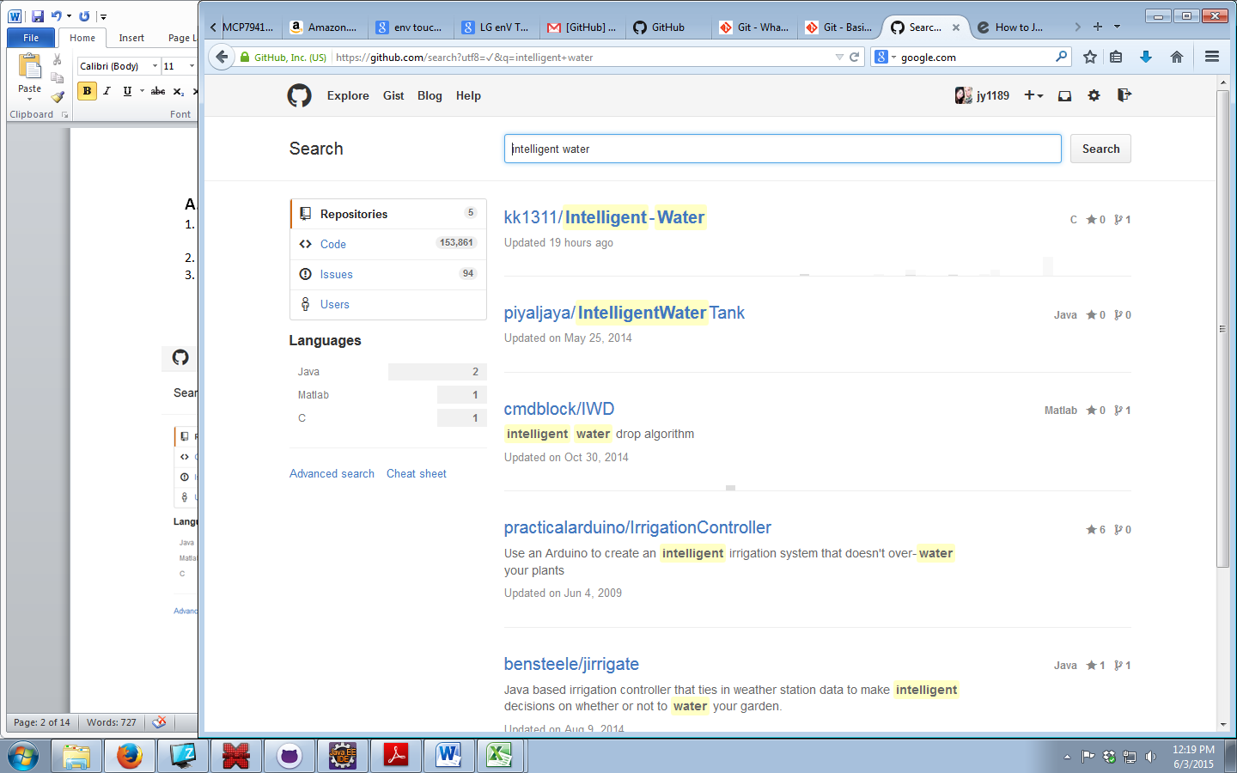

1. **Downloading GitHub and saving a new document**
2. Download github on <https://github.com/> (you may need to get Paul Myers or IT to give you permission to download it onto a school computer)

(IT’s number: 717.796.1800 x3333)

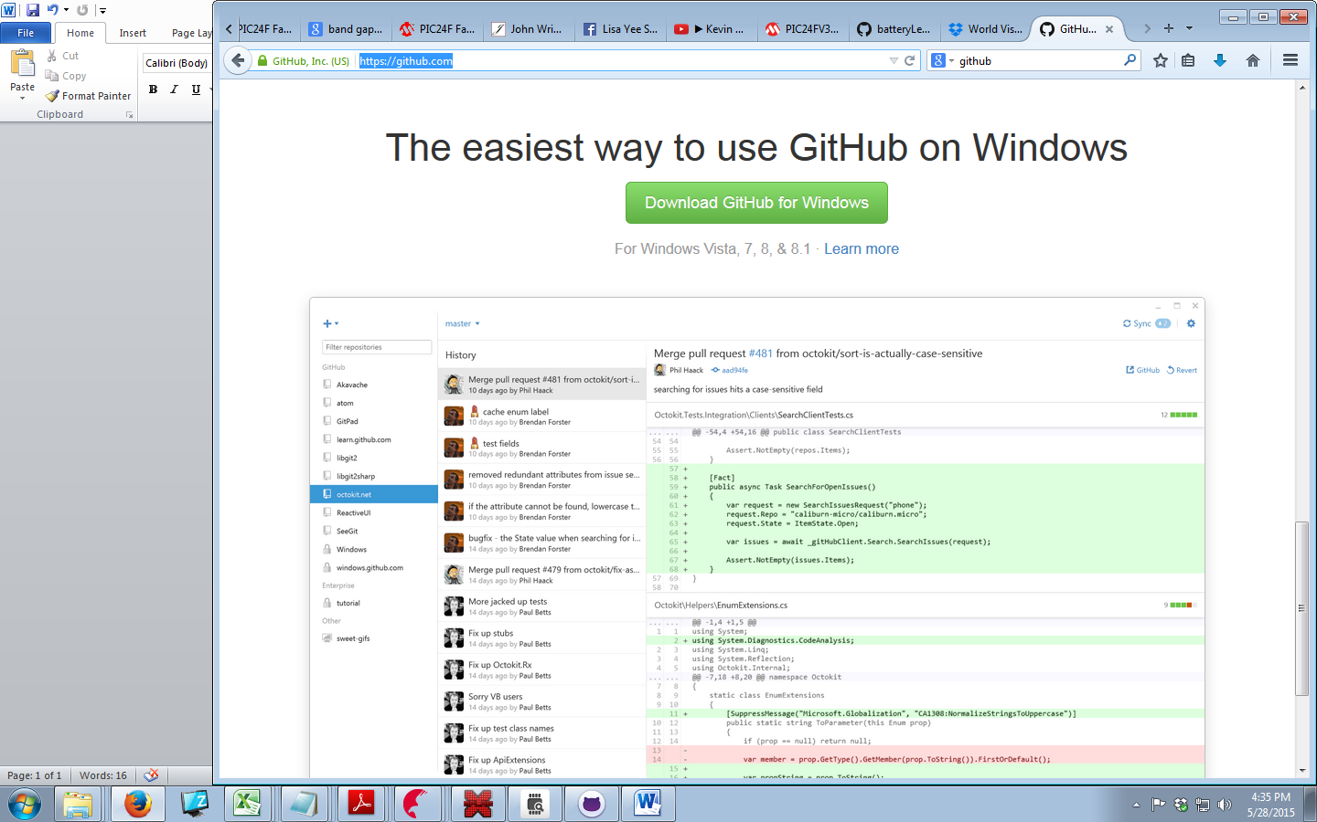

1. Open up the GitHub **folder** which should now be on your desktop

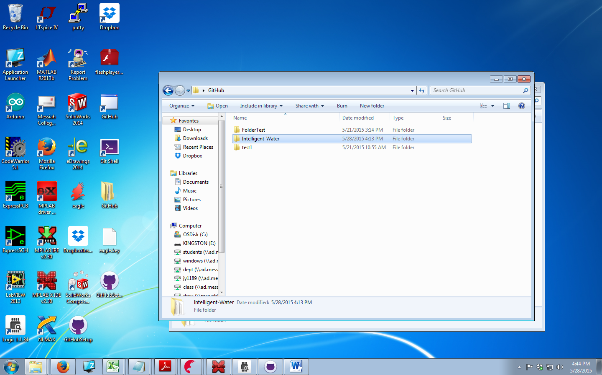

1. Select where you want to save your new file

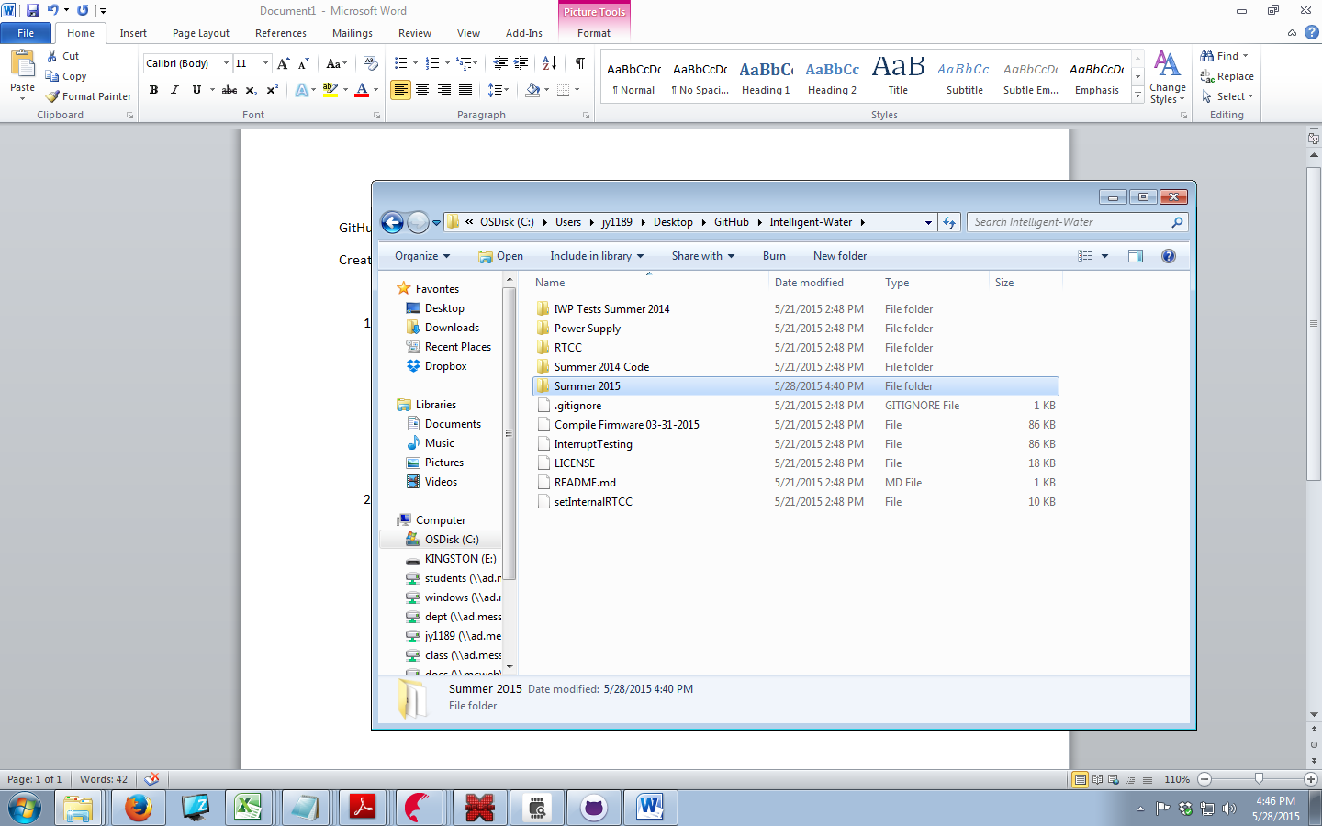

1. Now open up GitHub on your desktop, and Sync the file.

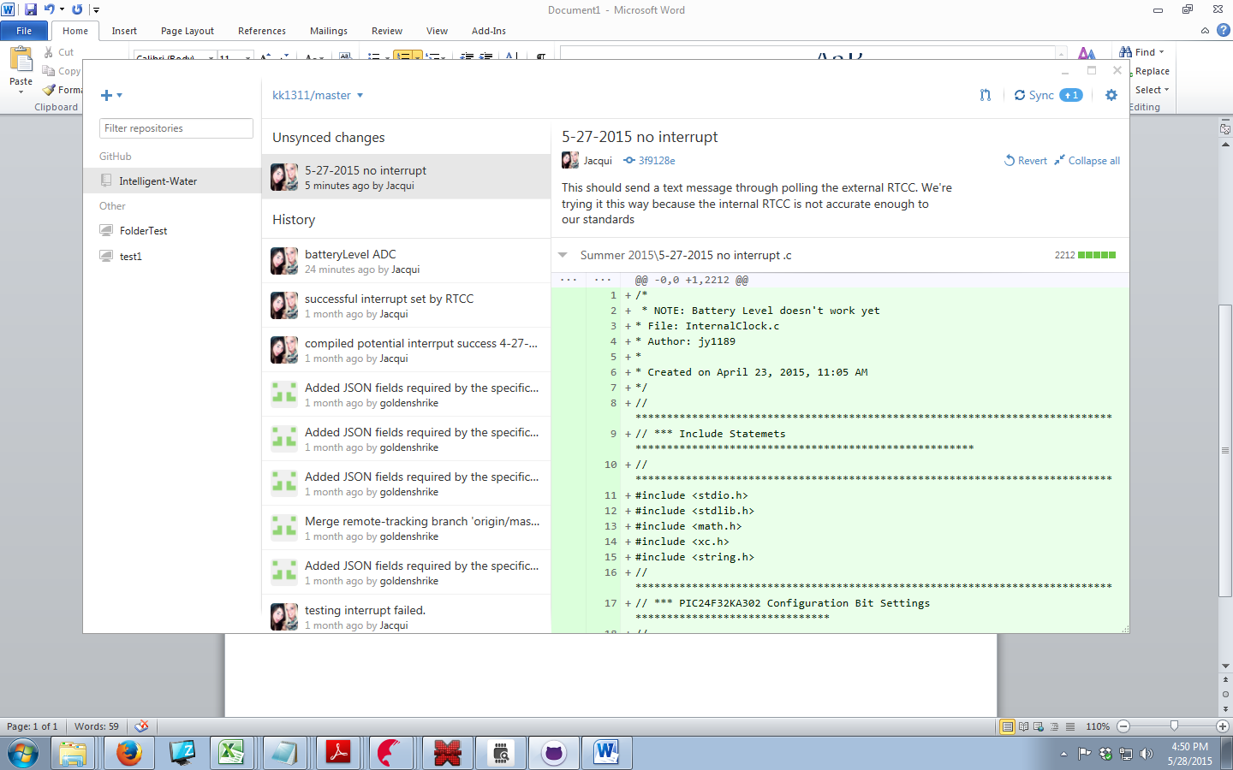

1. **Opening a current document in GitHub**
2. Open up github.com and log in.
3. Click on our project

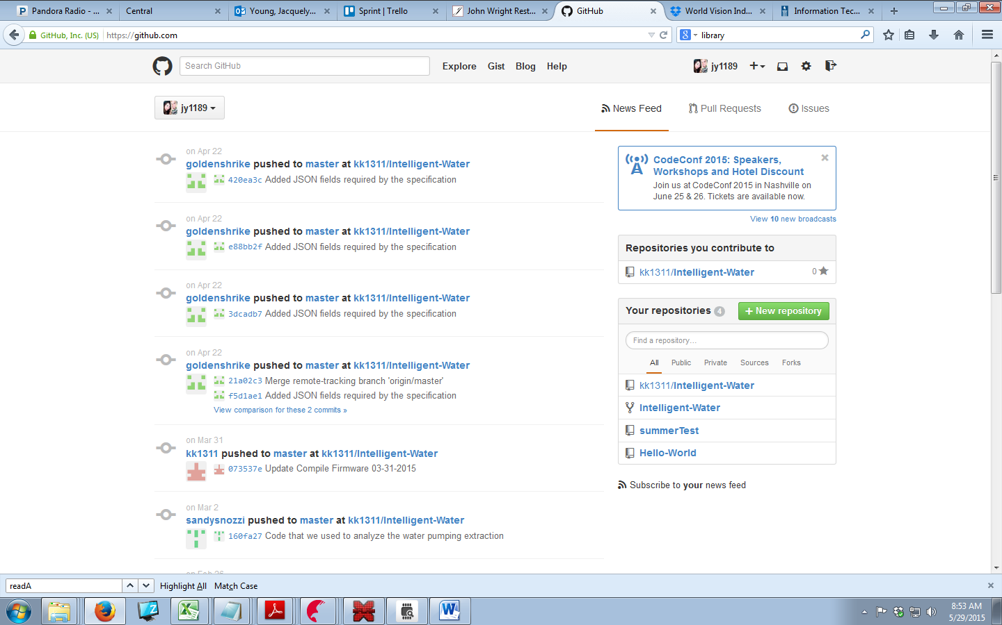

1. Click on the branch (folder) you want

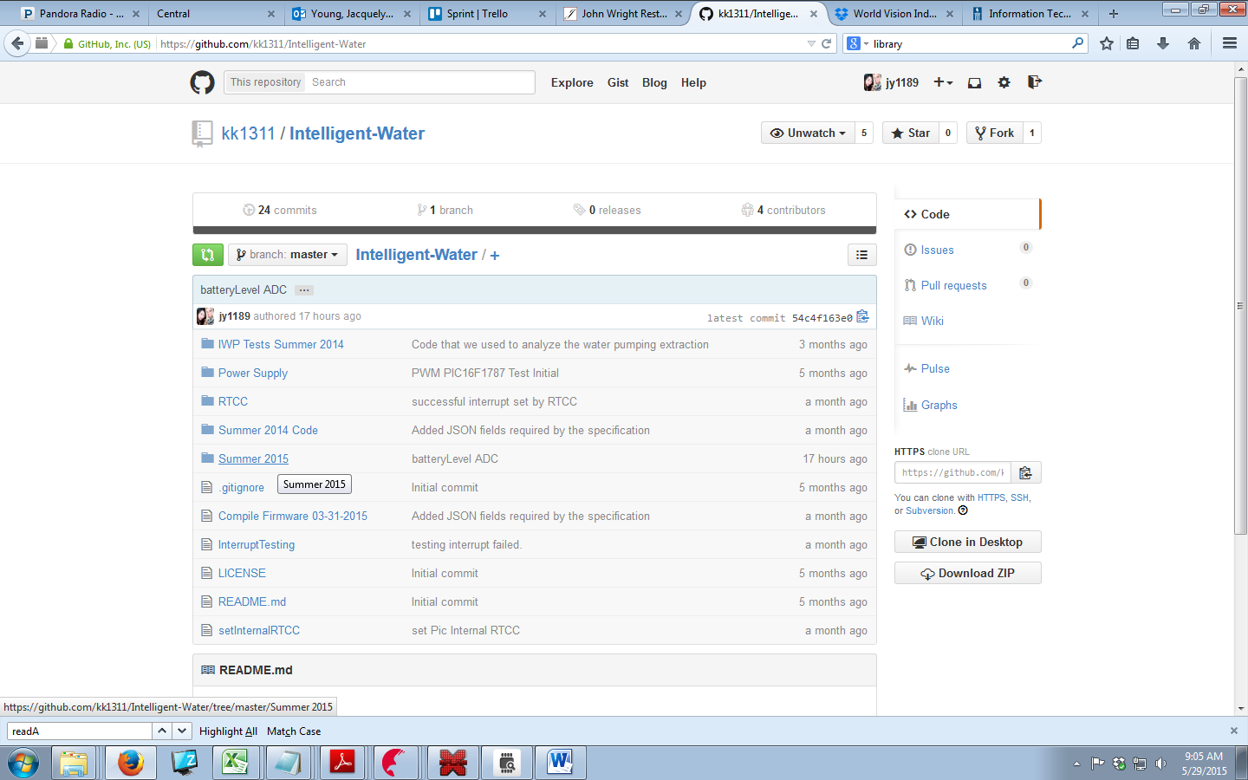

1. Add a “mini title” for changes made with a detailed description to go underneath to help those in the future. After you have completed this commit the file to master.

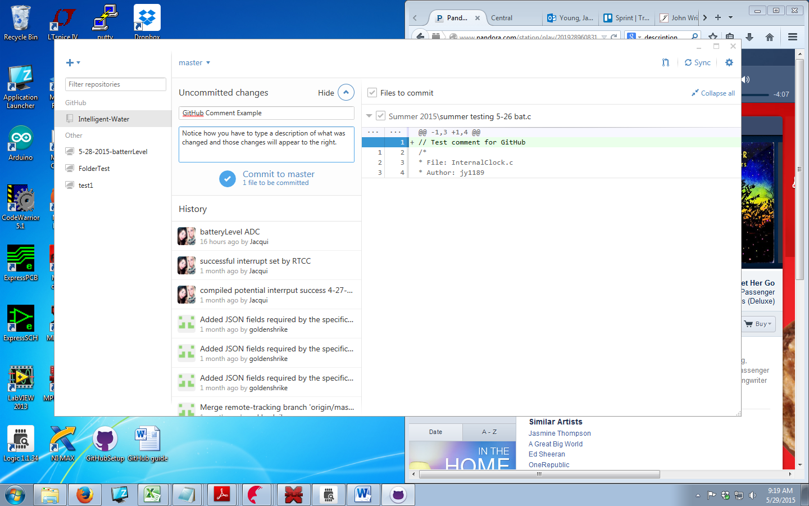

1. Remember to Sync the file!
2. **How to make a folder in GitHub**
3. After you downloaded GitHub you should have also downloaded a GitHub folder. Open it. Then open up the Project you want to make a folder in. Right Click > new > Folder

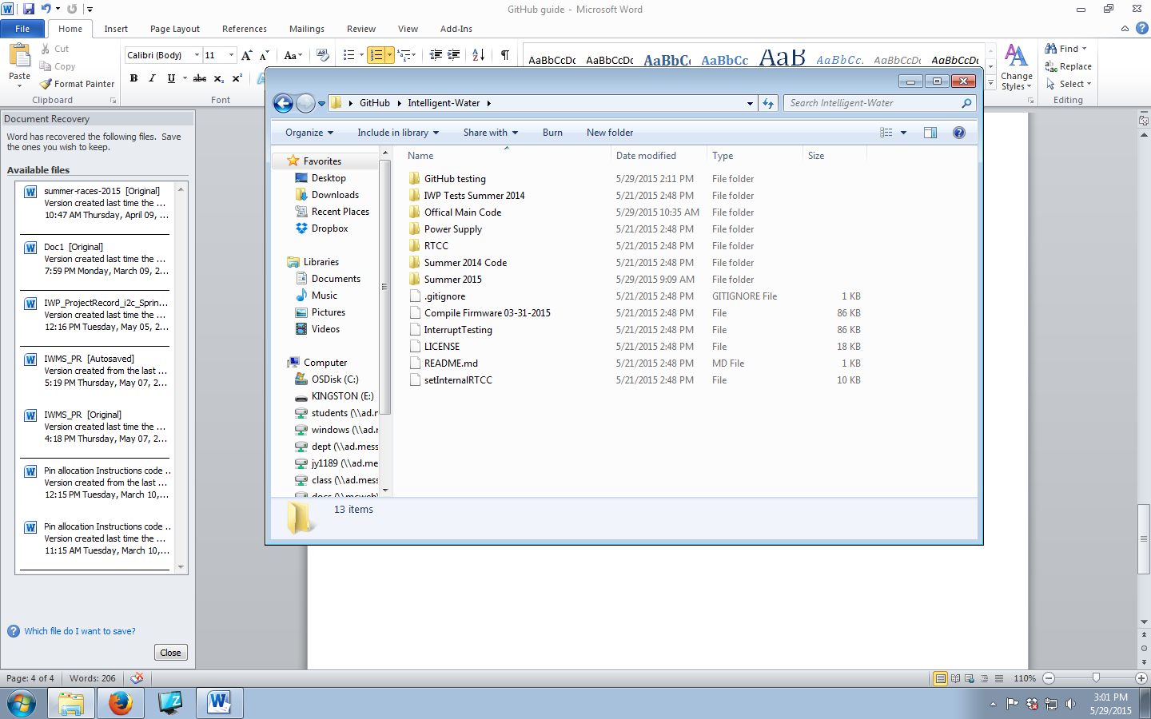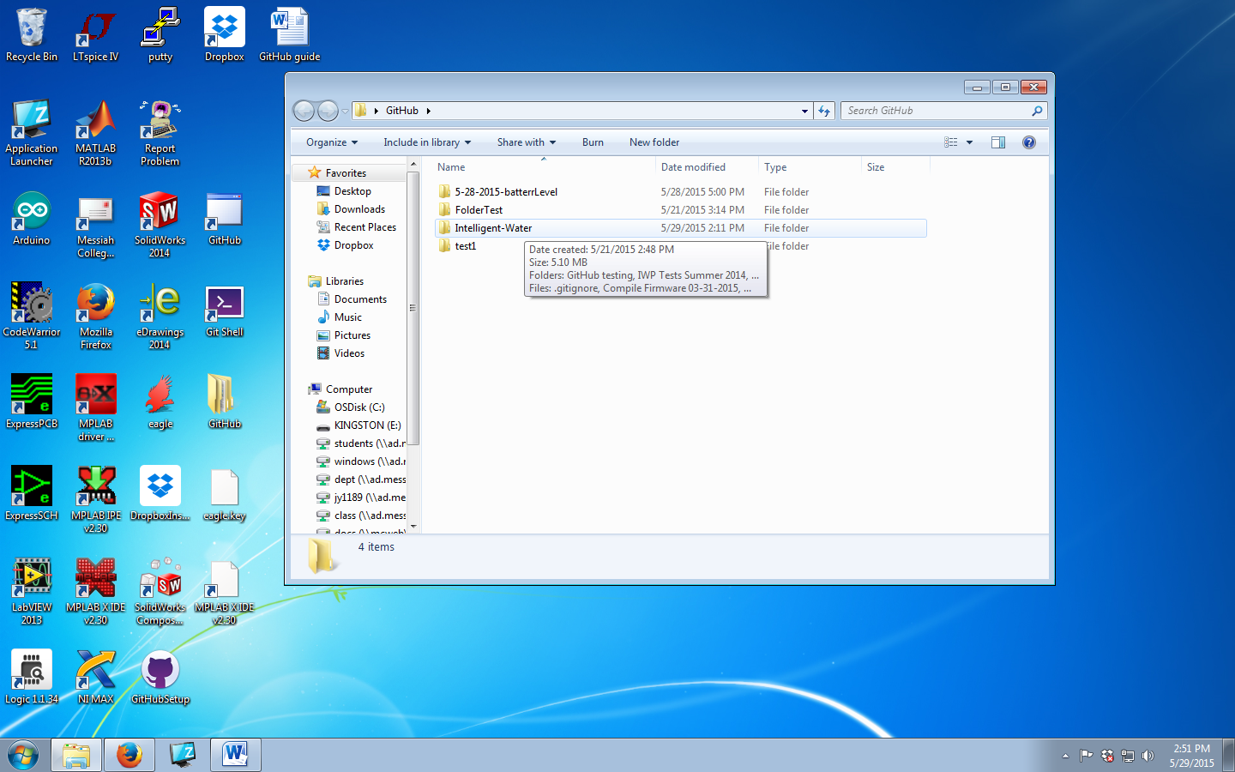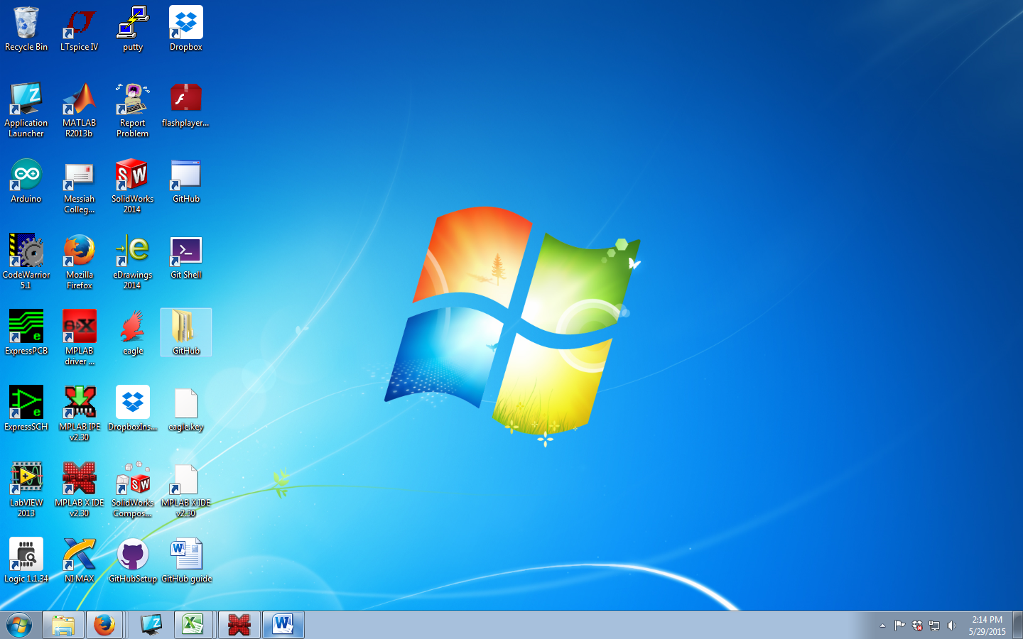

2) For this folder to appear online, there must be a document inside the folder.

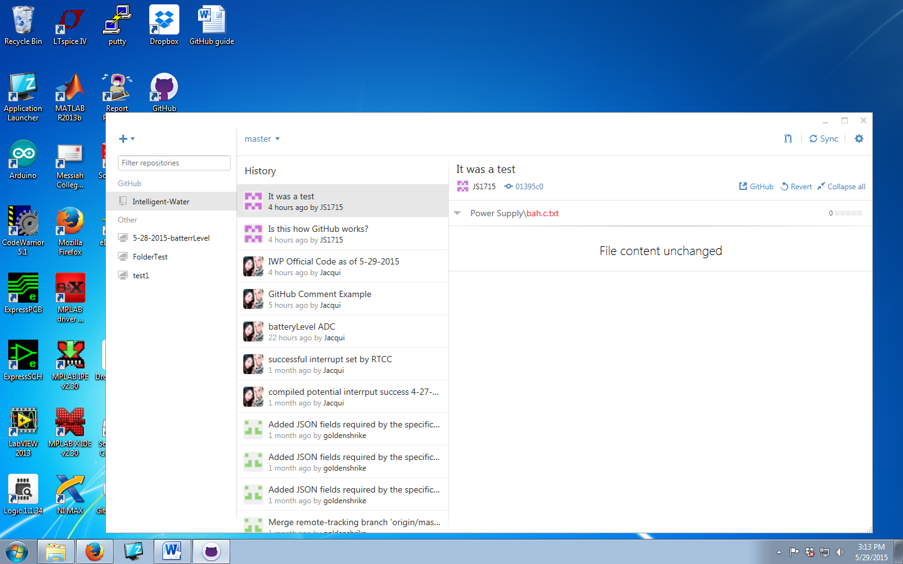

1. Transferring who is in charge of a repository
2. The current person in ownership of the repository needs to initiate.
3. The owner of the repository needs to click on the repository you want to move.

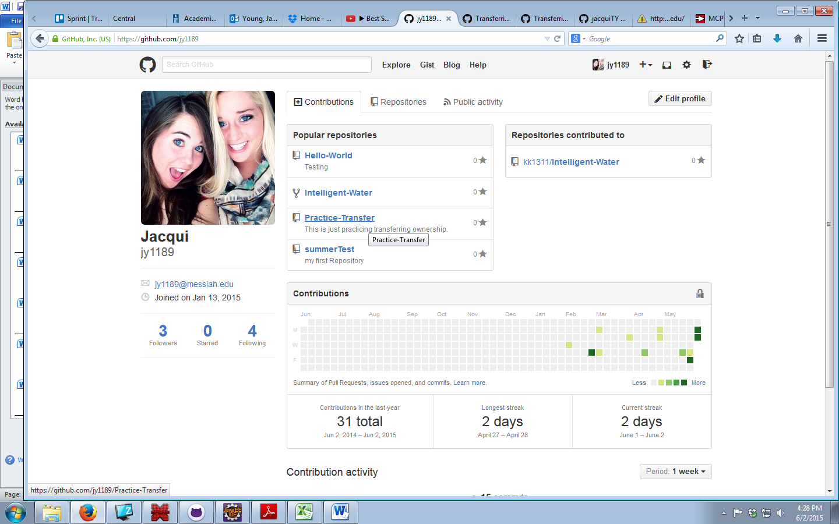

1. Then click on settings.

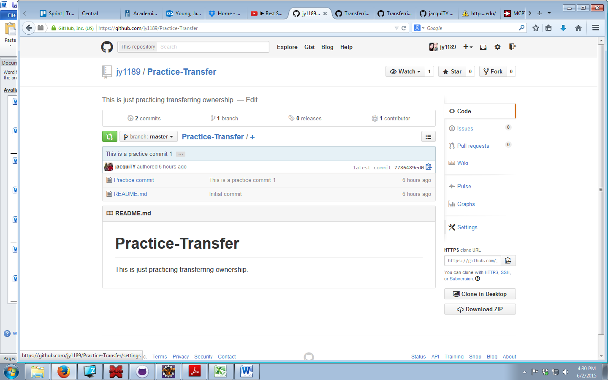

1. Scroll down to the “Danger Zone,” and click Transfer.

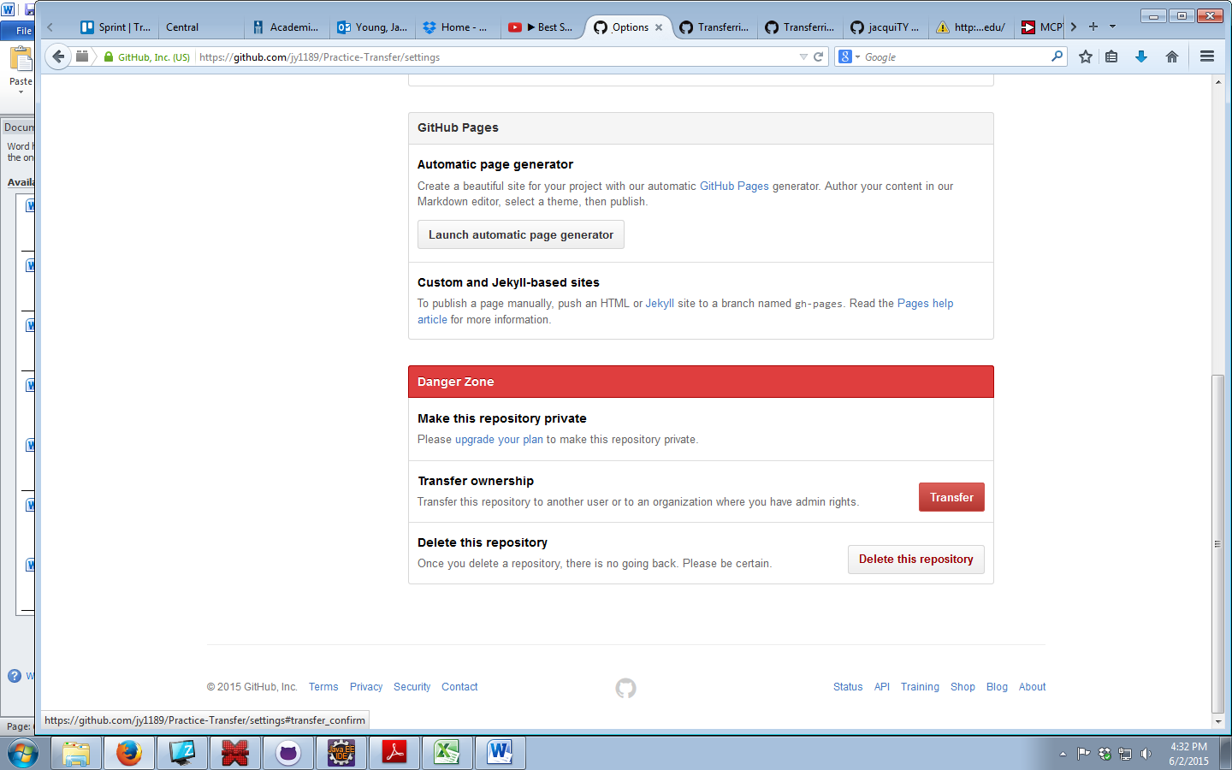

1. Next you will need to know the **name of the repository** you want to transfer as well as the **username** of the person you want to transfer it to.

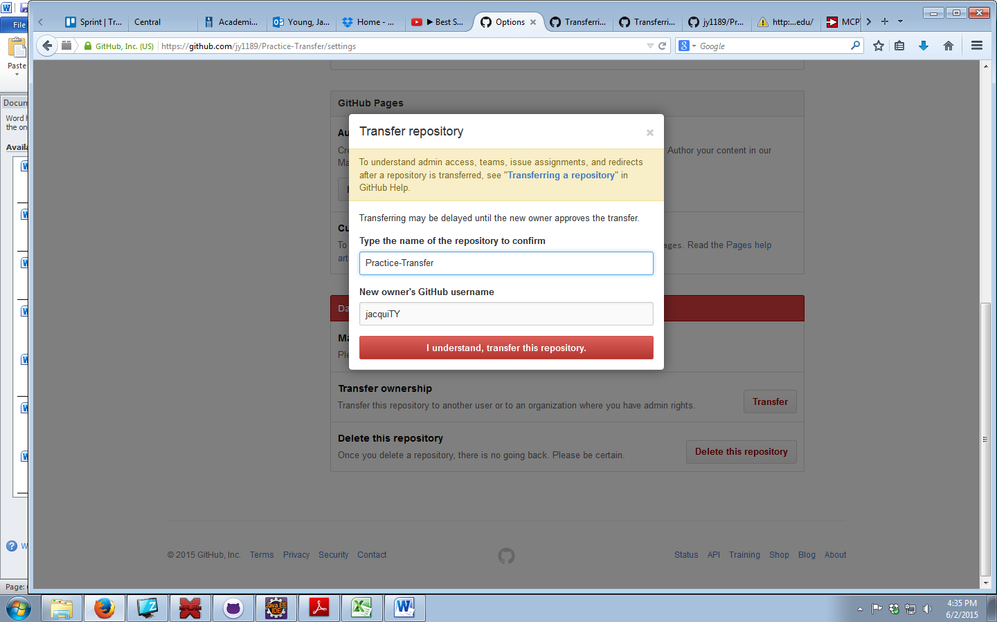

1. You will then have to confirm your password.
2. An E-mail has now been generated and sent to the new owner (if they accept). You are still in charge of this repository until they accept it. They have about a day to accept it, if they don’t accept nothing has changed.
3. The future owner needs to log on to their email and click the link that they accept the position as the new owner of the repository.

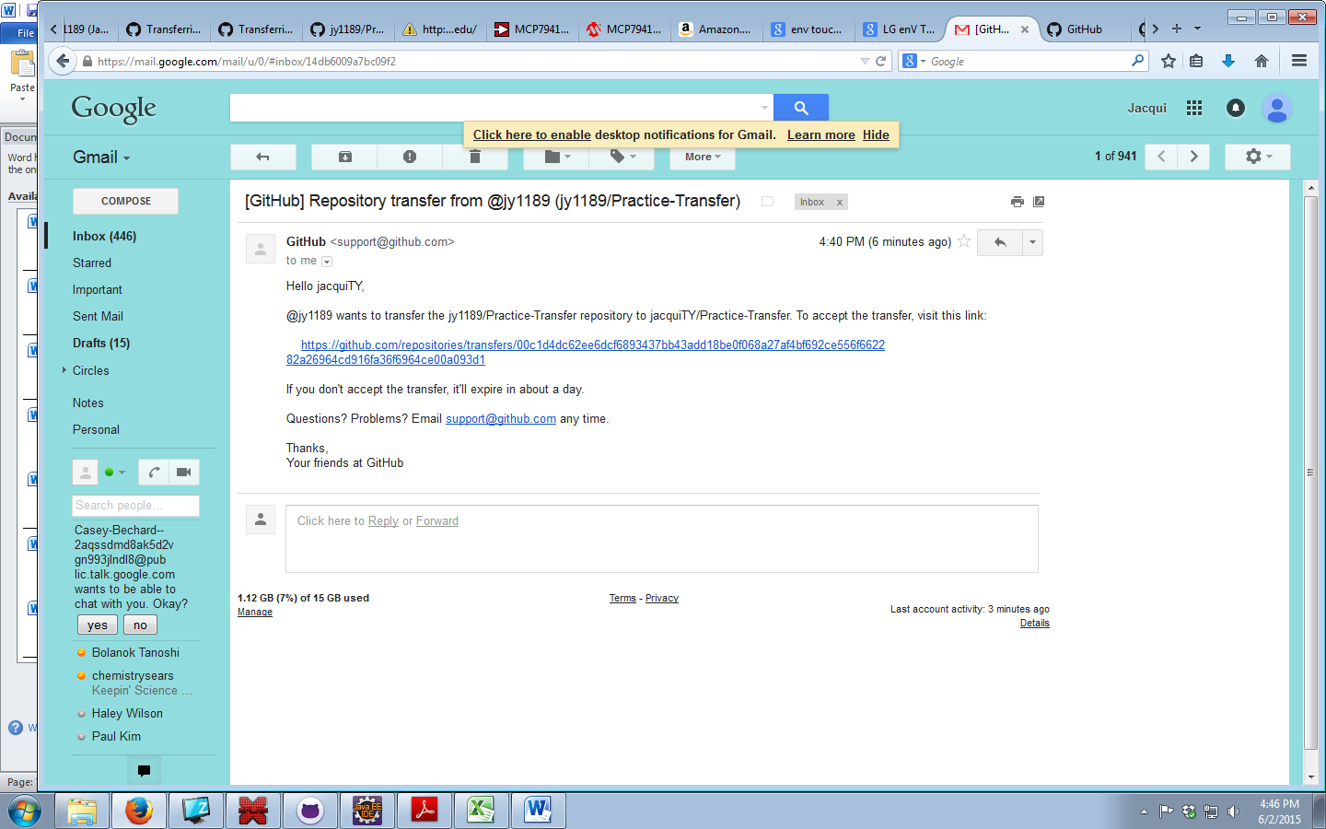

1. The new owner will then be taken to GitHub where they need to log on to make the transfer permanent. Once you do that you will see a message displayed letting you know you successfully accepted the transfer.

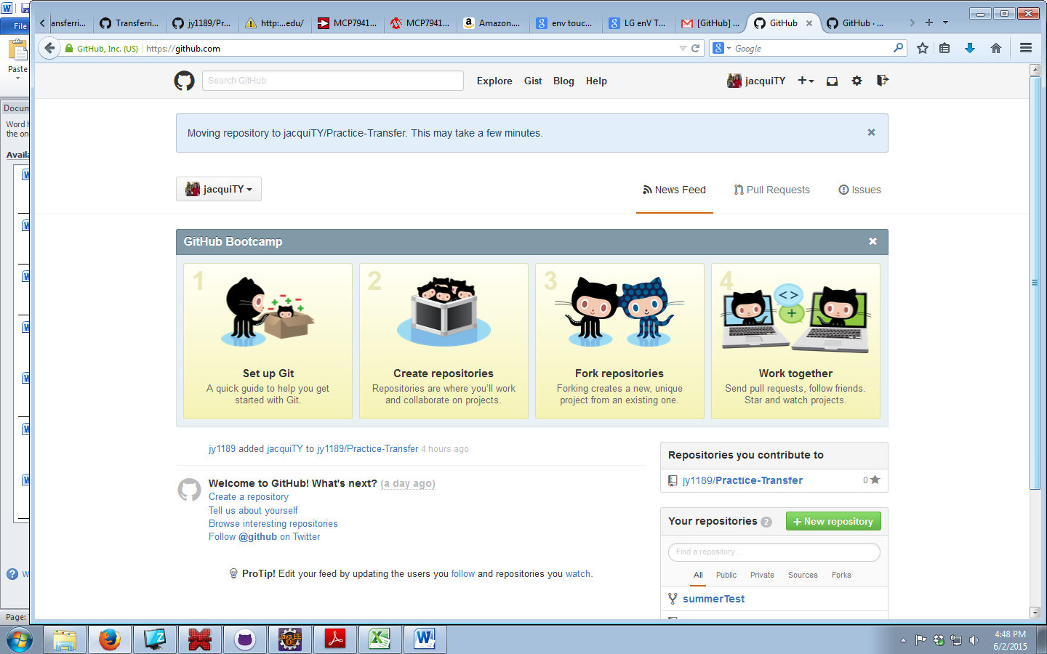

1. The previous owner should receive an e-mail when the new owner accepts ownership.

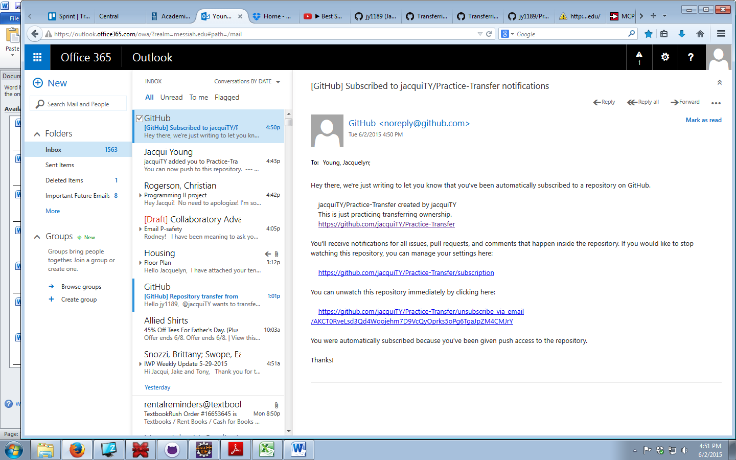

1. **Making a repository**

Note: Intelligent has its own repository and you should most likely use that for the project. If you want to work on an independent project though, this section is for you!

1. Go to the upper right hand corner and click on the plus sign and click “New repository.”

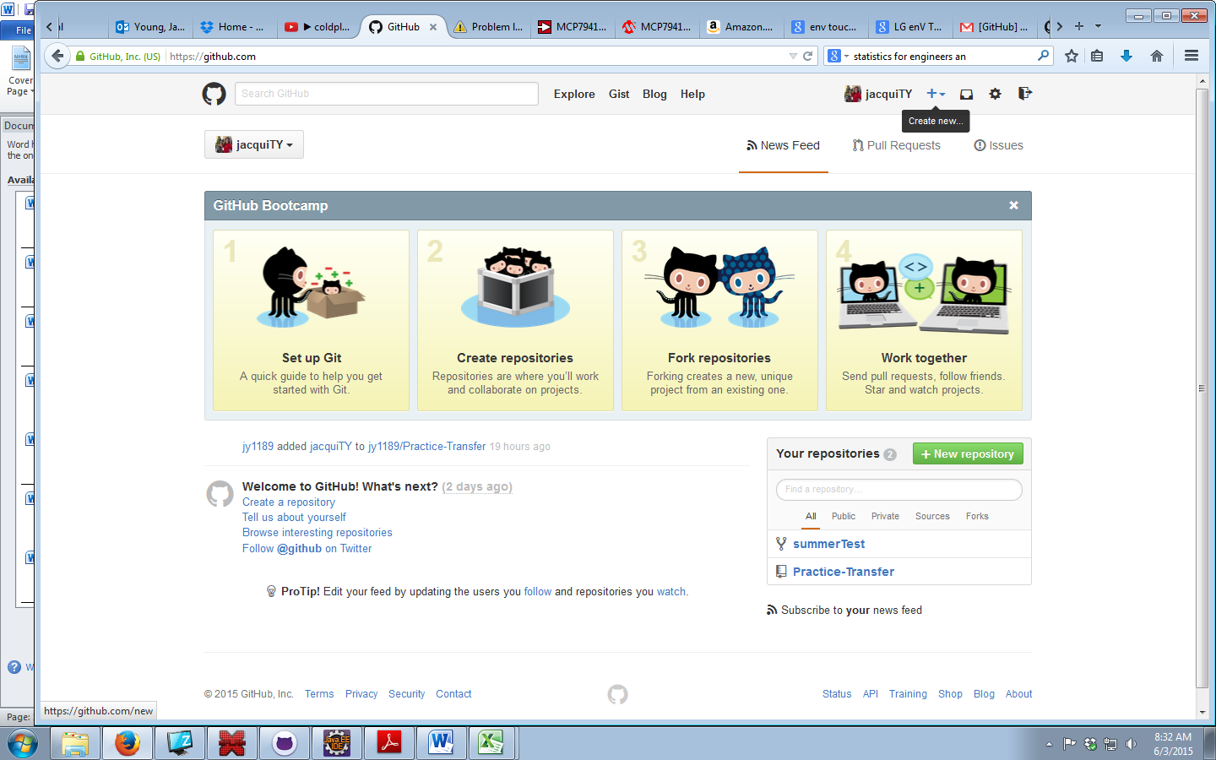

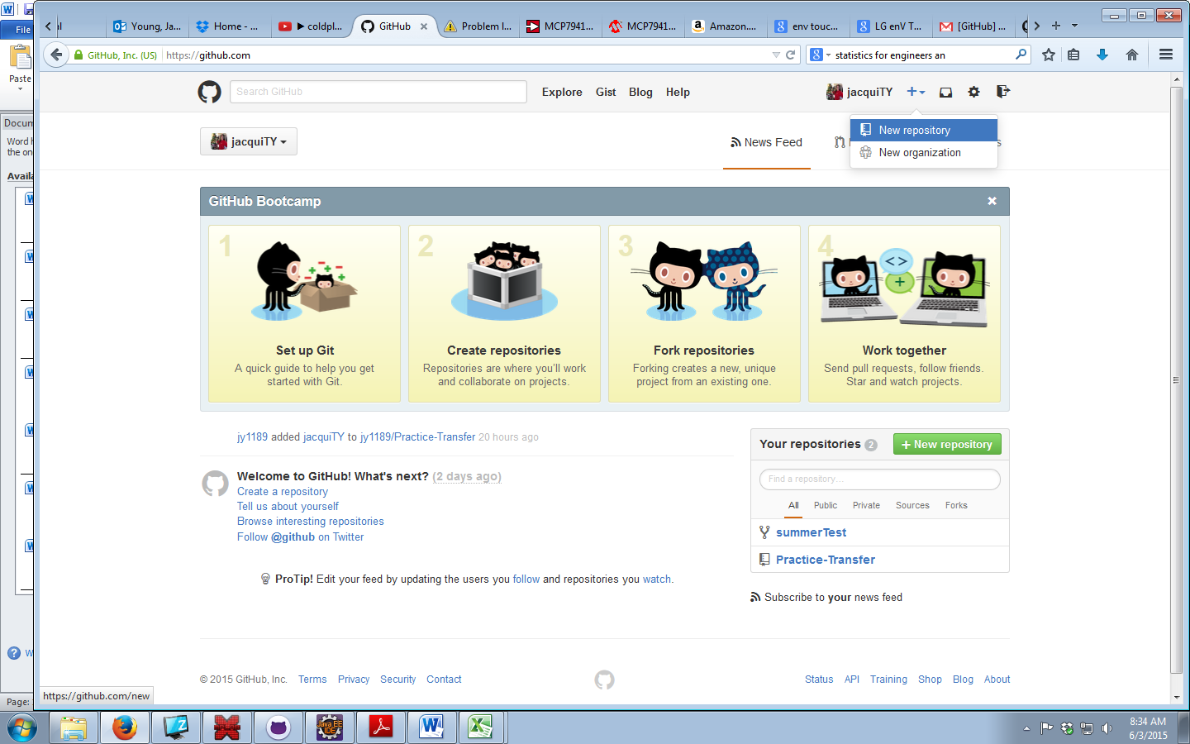

1. Type in the name of your repository and a description (which you can edit later). Note: spaces will turn into “-“, and to make something private costs $7 / month. I’d recommend Initializing this repository with a README.

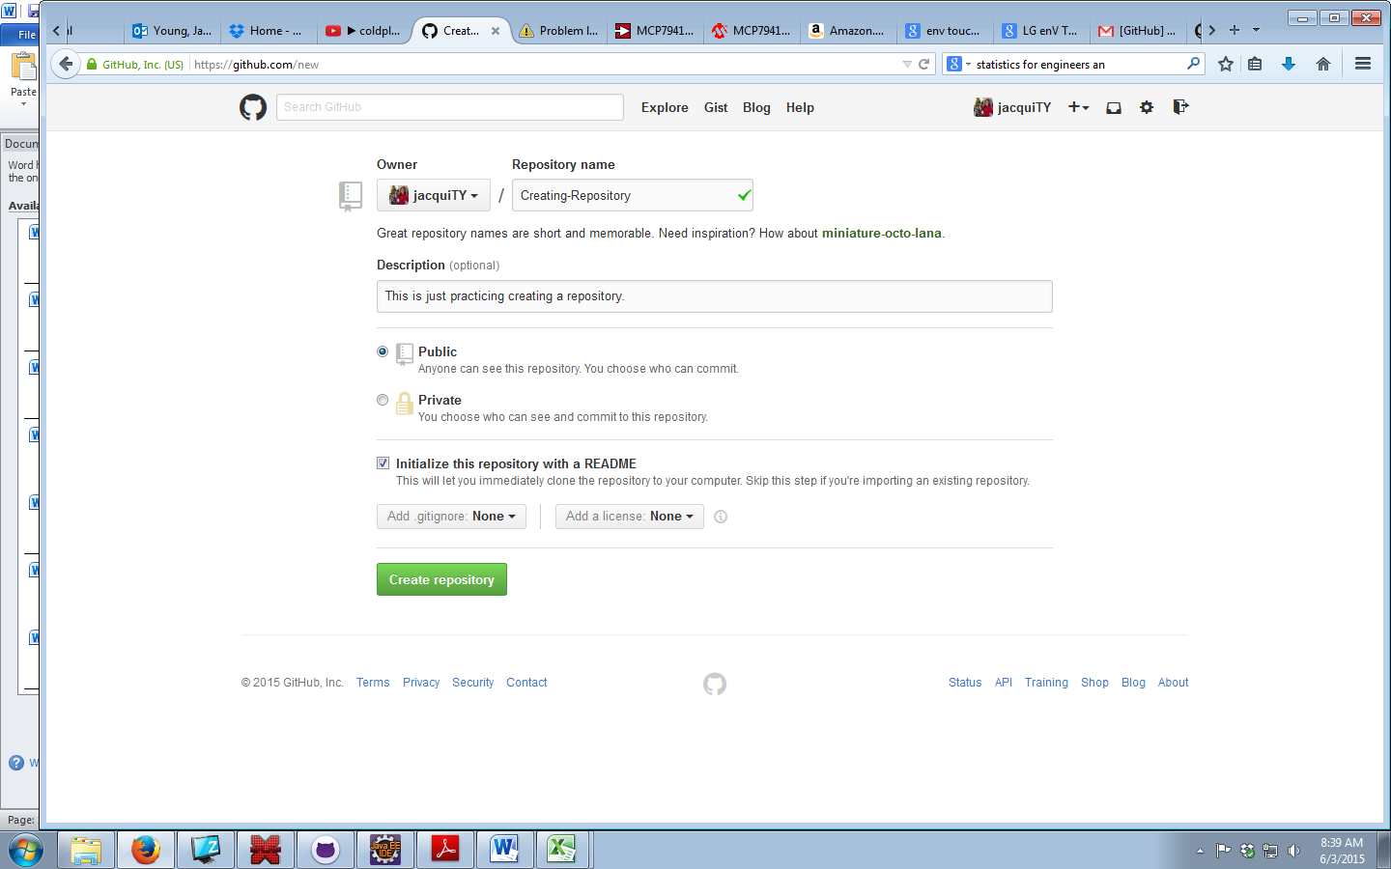

1. You successfully created a repository! Just remember you can’t make folders if GitHub hasn’t been downloaded to your computer. However you can still upload files.

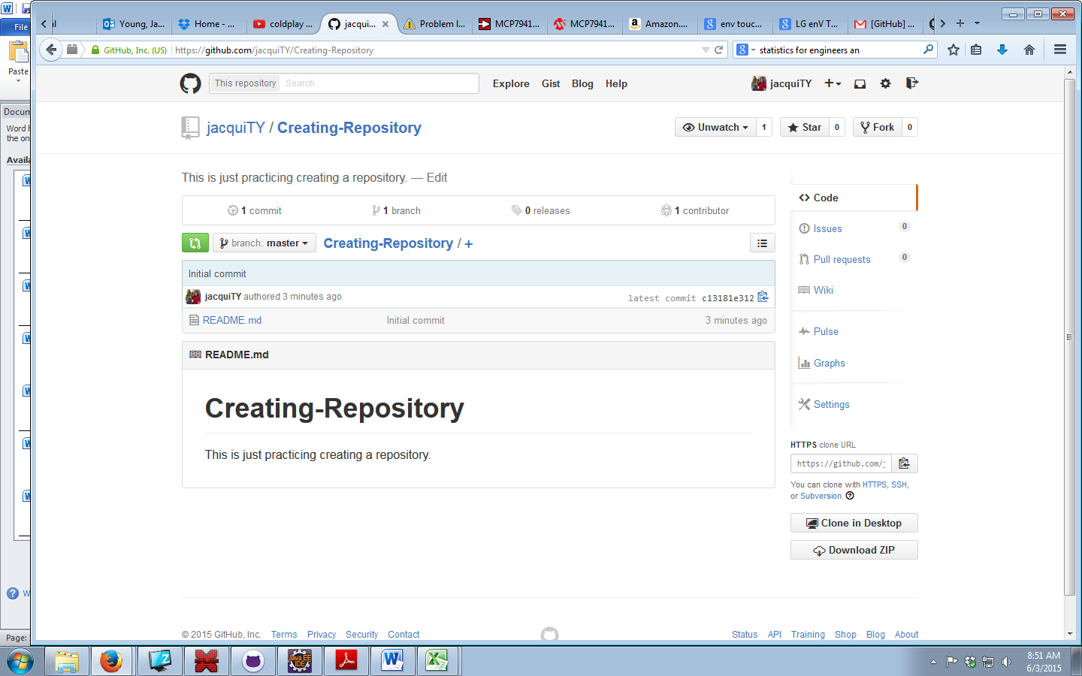

1. **Vocabulary**
2. **Repository:**
3. **Commit:**
4. **Pull:**
5. **Push:**
6. **Fork:**
7. **Branch:**

Extensive explanation found at:

https://git-scm.com/book/no-nb/v1/Git-Branching-What-a-Branch-Is

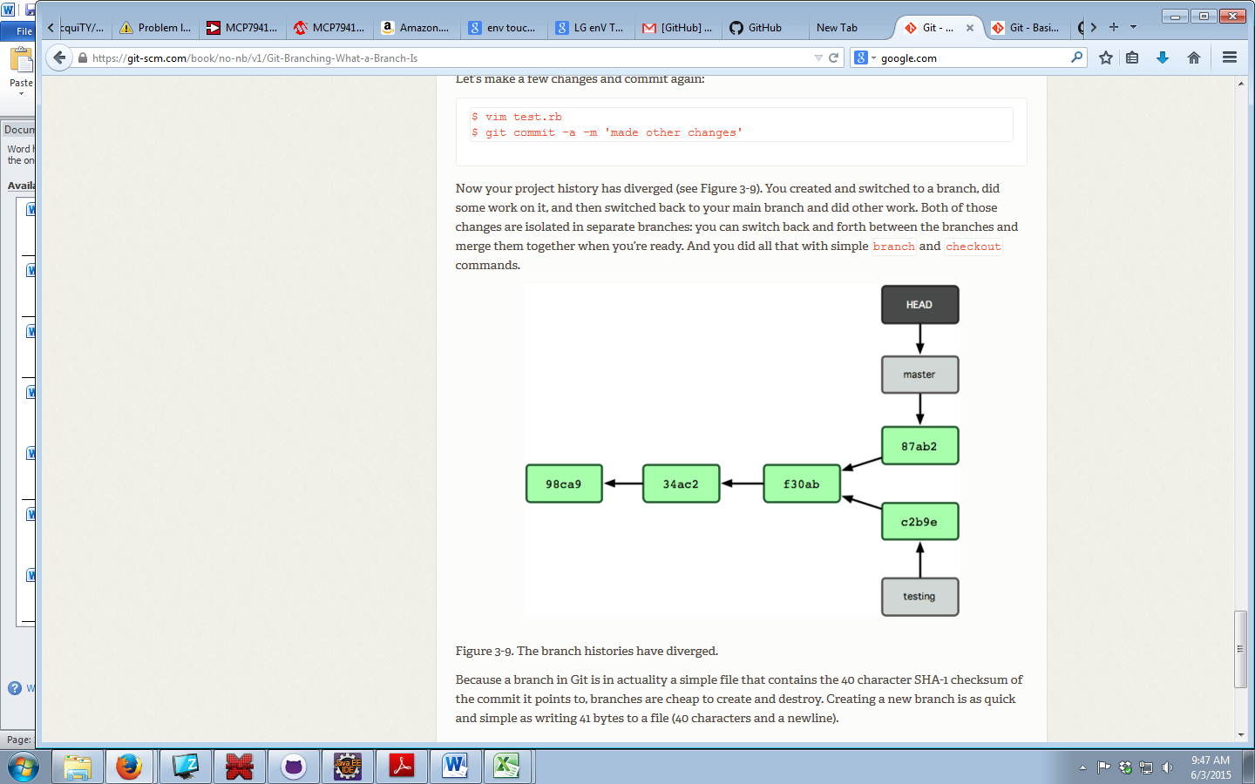

The Gray boxes are two separate branches. It’s like a history line that splits at a point, but you are able to view both histories by switching between them. It is even possible to compare the different histories to see what is different and merge them.